Launch of Cucumber Test

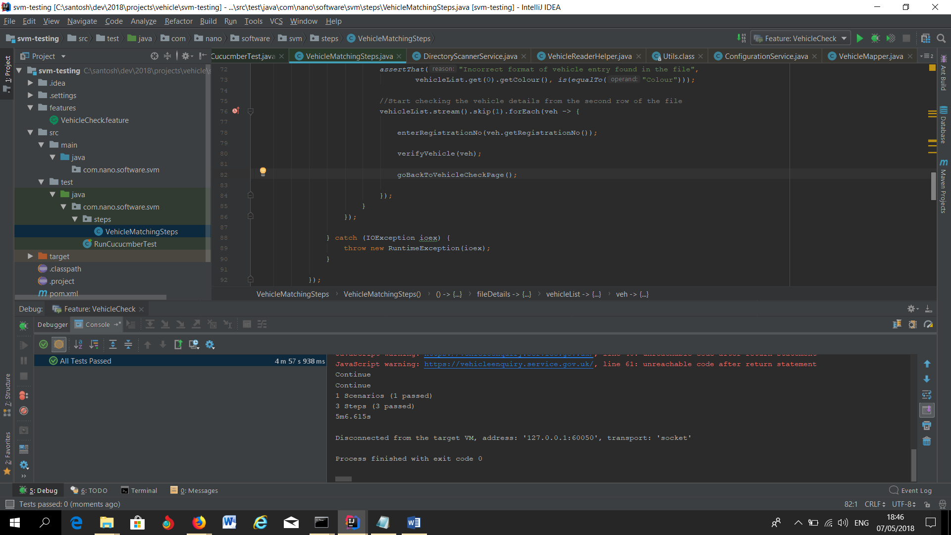

Launch base url of the site

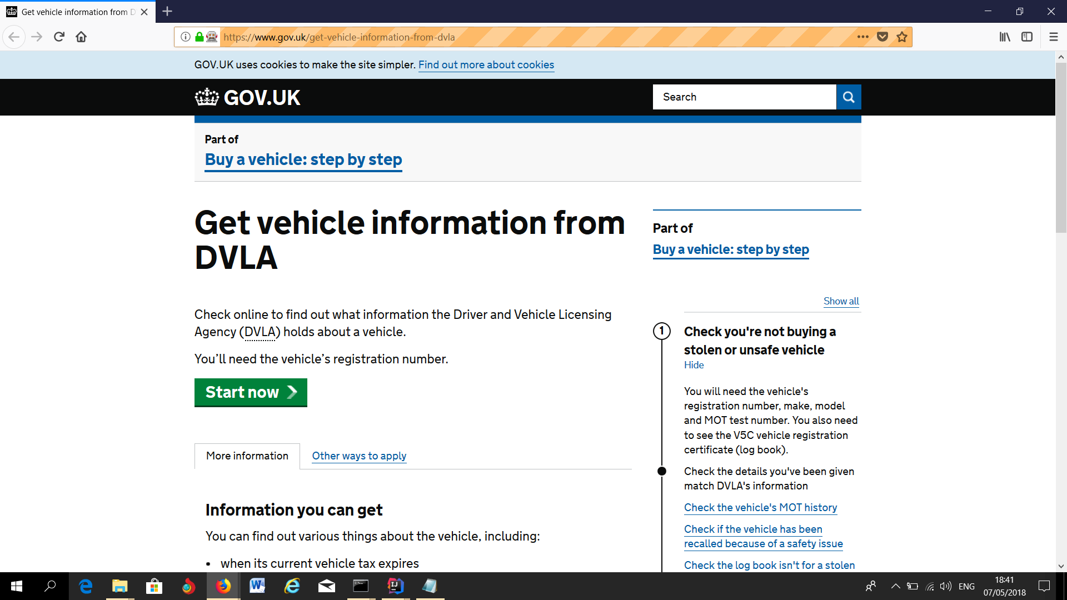

Checking of first Vehicle (LG11 LHR) starts

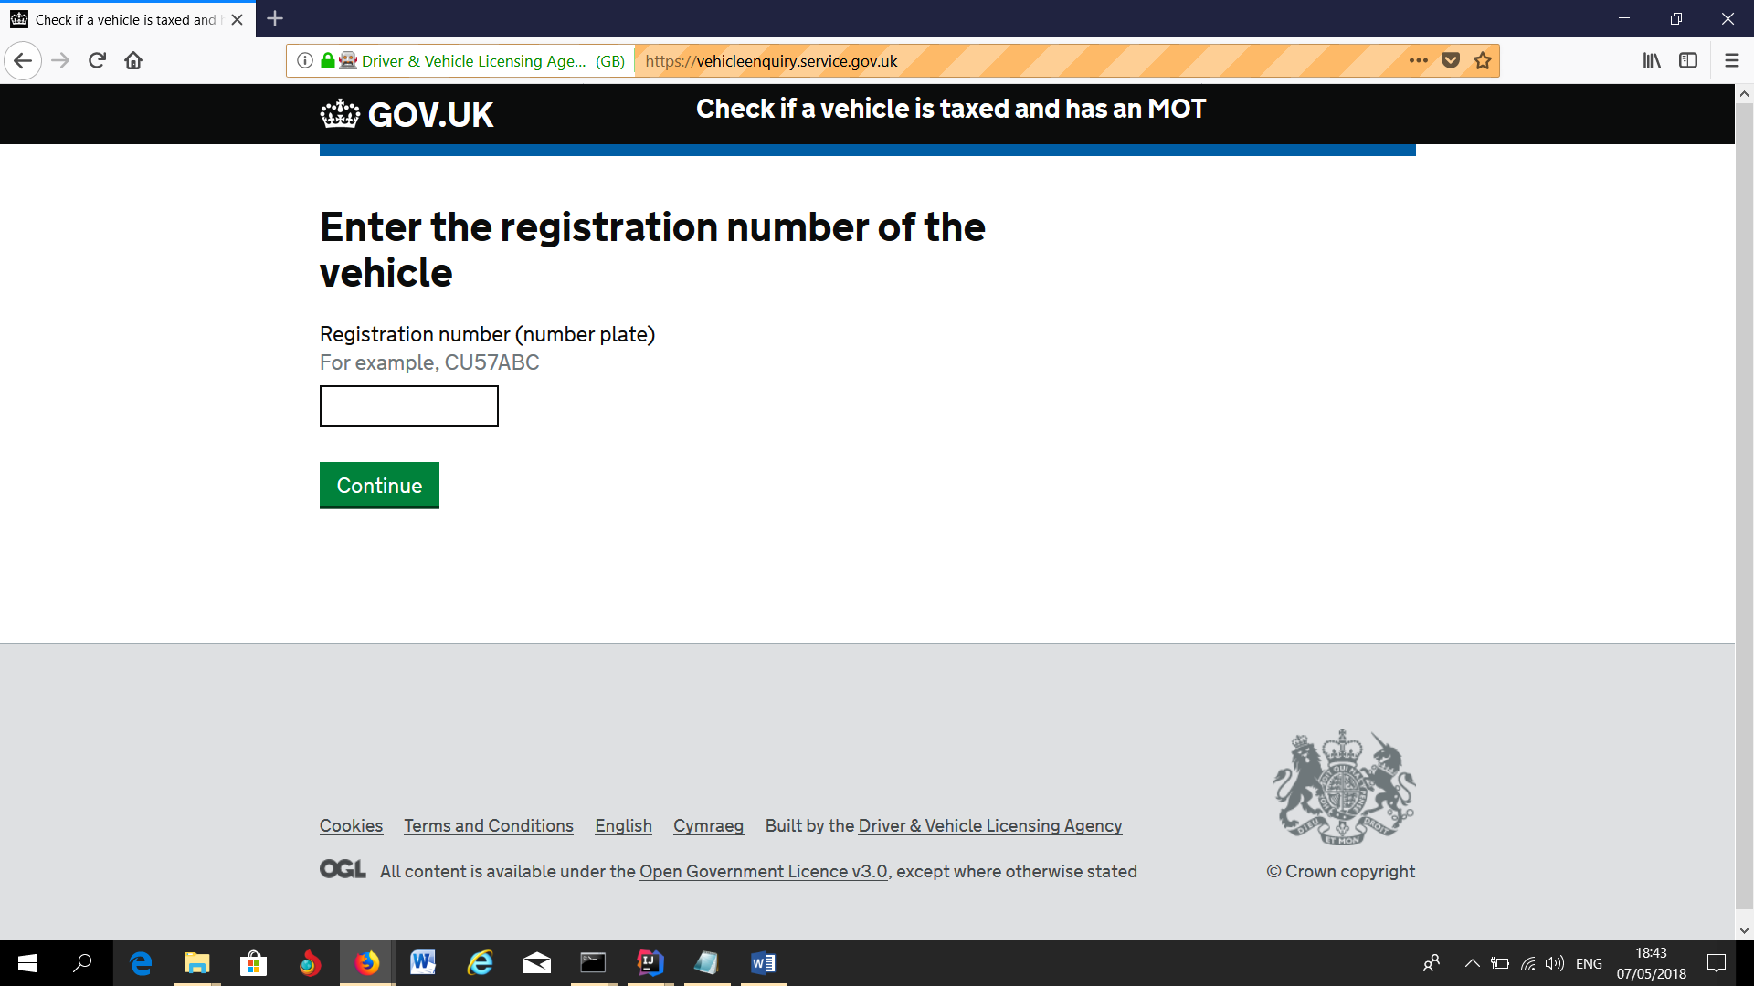

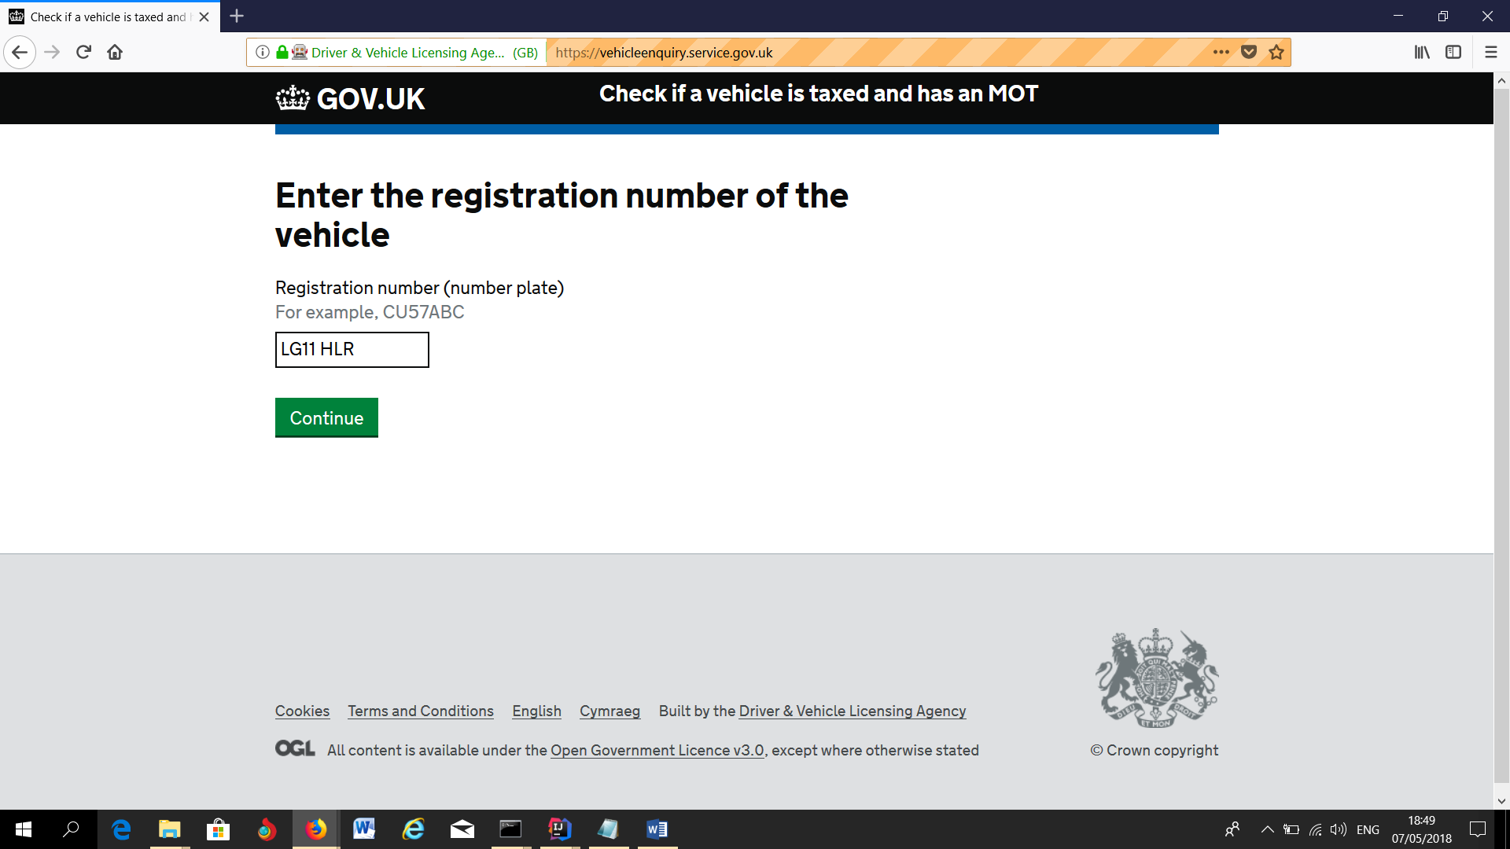

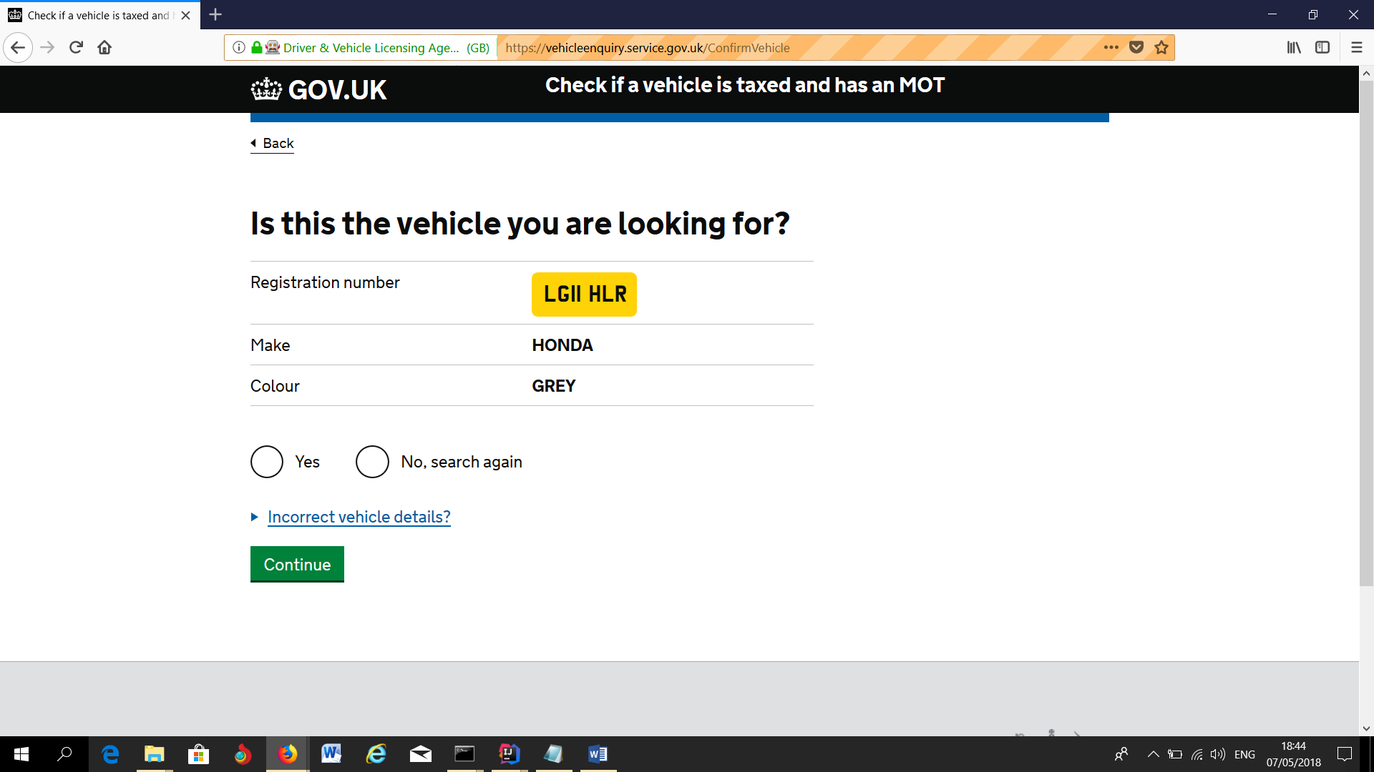

Checking of first Vehicle (LG11 LHR) ends

Checking of Second Vehicle (X298 HBA) starts



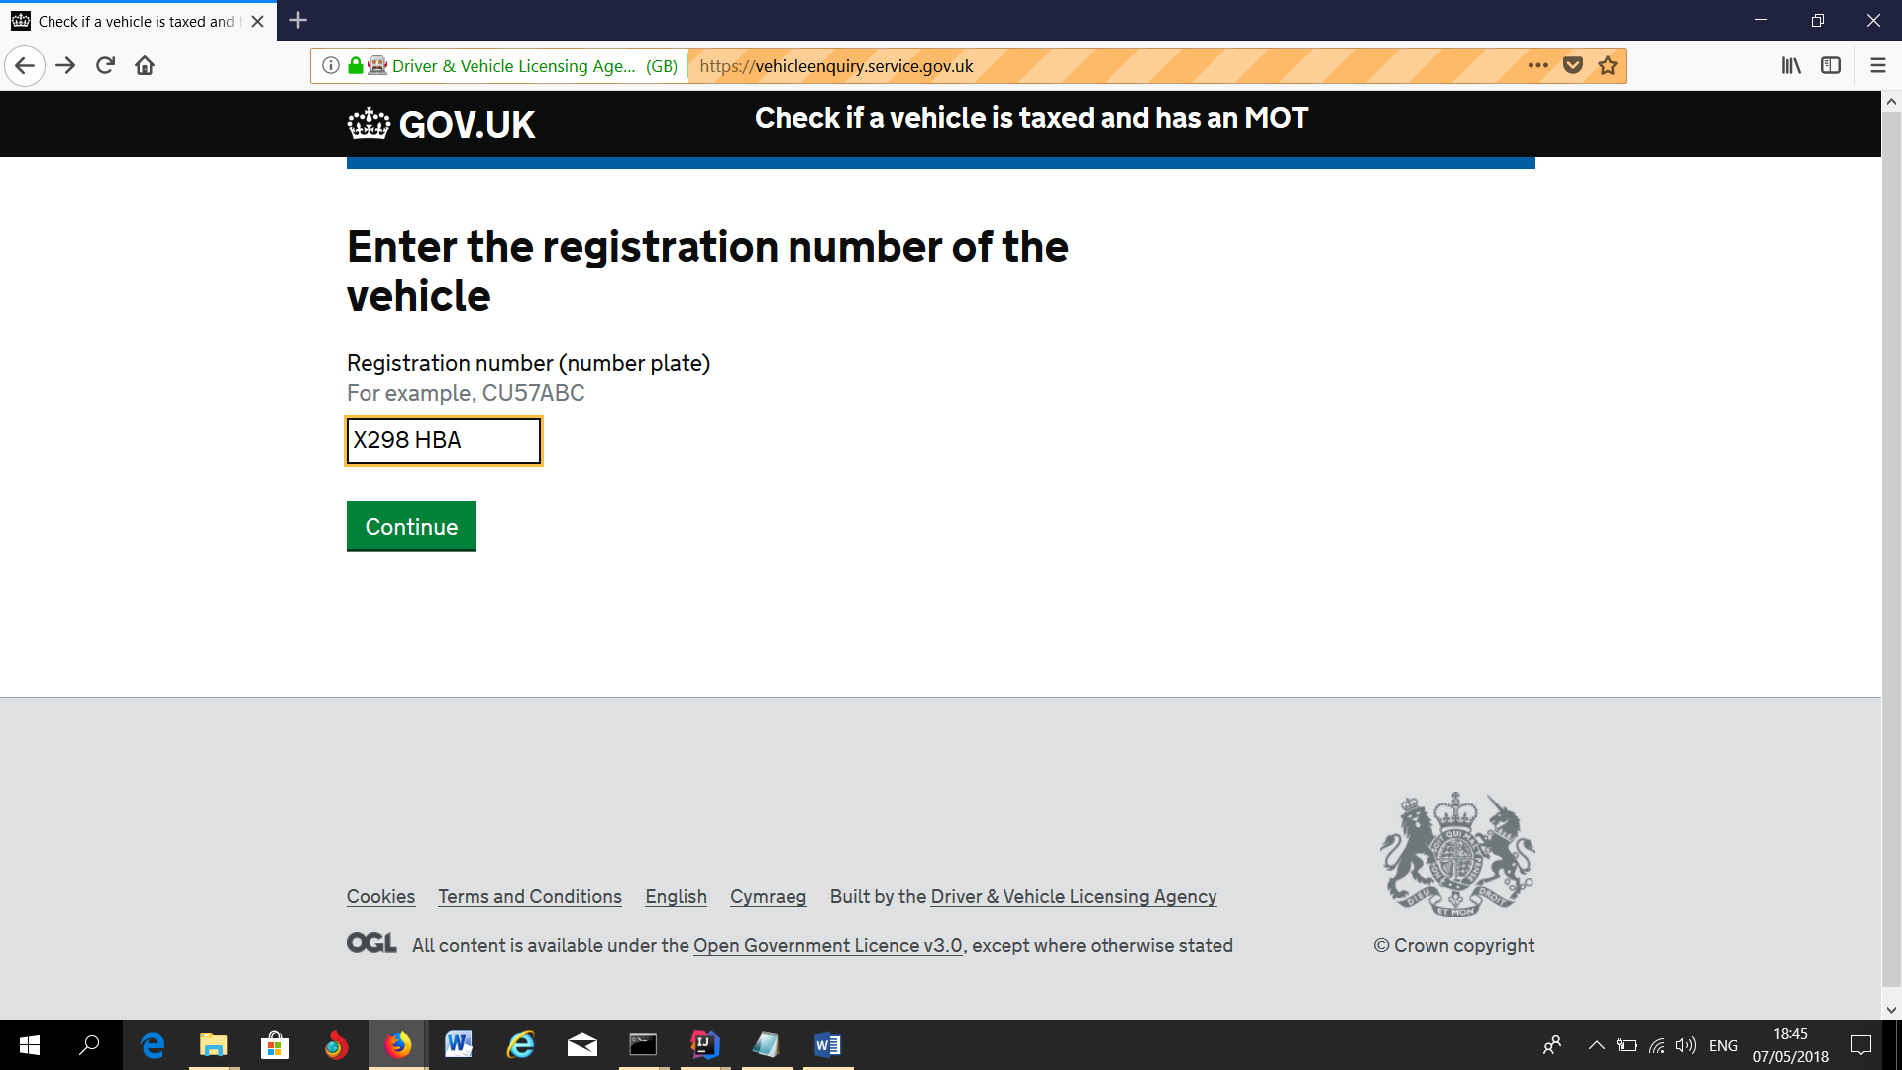

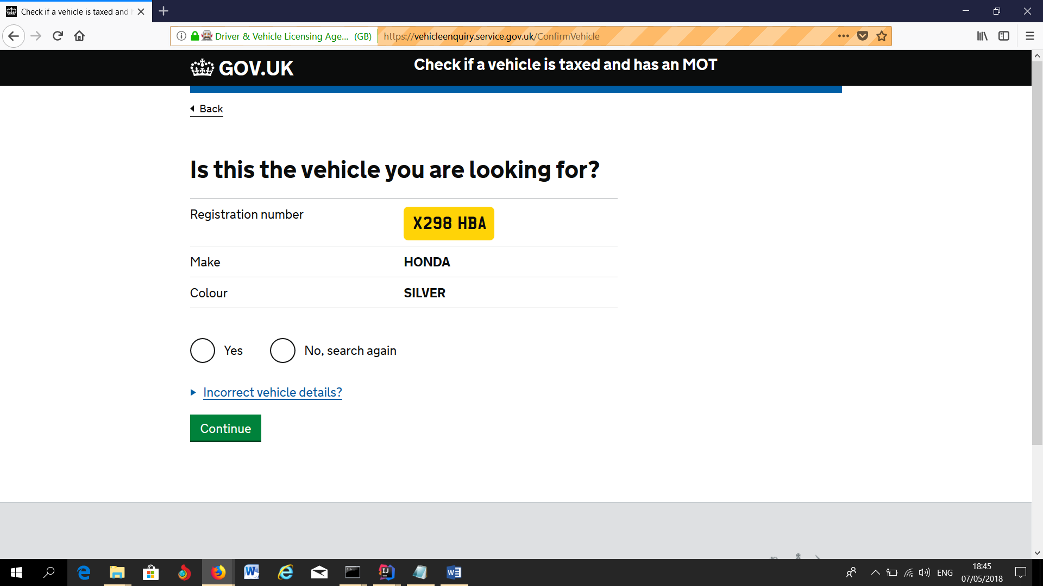

Checking of Second Vehicle (X298 HBA) ends

All test steps passed

